**A Report on**

**Exploratory Data Analysis on the Titanic Dataset**

By Sayan saha

10th June 2025

**Introduction**

This report presents the findings from an exploratory data analysis (EDA) on the Titanic dataset, which aims to understand the relationships between passenger attributes (e.g., age, sex, class) and survival outcomes. The analysis uses Python libraries such as Pandas, Matplotlib, and Seaborn.

**Data Description**

The dataset consists of the following columns:

* **PassengerId**: Unique identifier.
* **Survived**: Survival status (0 = No, 1 = Yes).
* **Pclass**: Ticket class (1st, 2nd, 3rd).
* **Name**, **Sex**, **Age**, **SibSp**, **Parch**, **Ticket**, **Fare**, **Cabin**, **Embarked**.

**Missing Values:**

* Age has some missing values.
* Cabin has many missing values.
* All the missing numeric values were fill with median of all the other age present in the column.

**Basic Statistics:**

* Average Age: [30].
* Average Fare: [32.093].

**Univariate Analysis**

**Age**

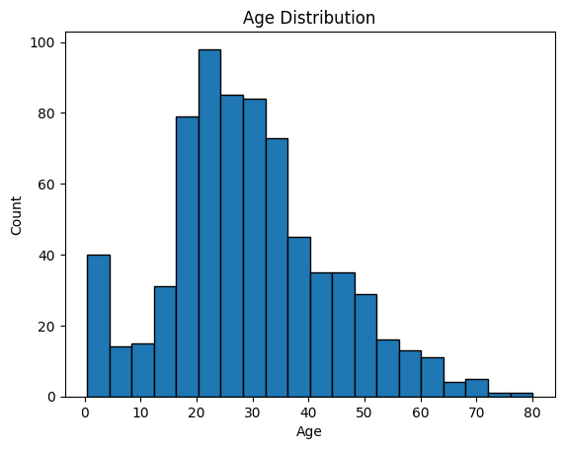

* Observation: Age distribution is right-skewed with many passengers aged between [insert range].

**Sex**

* Observation: There are more male passengers than female passengers.

**Pclass**

* Observation: Most passengers are in 3rd class.

**Bivariate Analysis**

**Age vs Survived**

* Observation: Younger passengers had higher survival rates.

**Sex vs Survived**

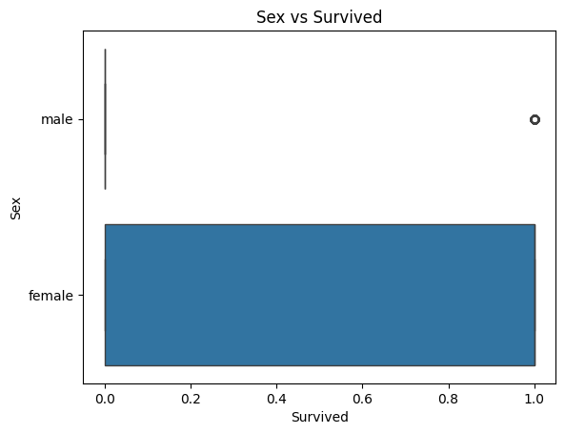

* Observation: Females had higher survival rates.

**Key Findings**

* Females had higher survival rates than males.
* Passengers in 1st class had higher survival rates.
* Younger passengers had slightly better survival chances.
* Fare was positively correlated with survival.

**Conclusion**

This EDA provided insights into factors influencing survival in the Titanic disaster. These findings will guide further steps such as predictive modeling or deeper feature engineering.